**CSE523 Machine Learning**

**Prof. Mehul Raval**

**Analyzing TCP Network Packets**

**Week 3 Report**

| **Name** | **Enrolment Number** |
| --- | --- |
| Nityam Dixit | AU2040140 |
| Tej Thakar | AU2040262 |
| Yagnesh Patel | AU2040025 |
| Kavan Gondalia | AU2040030 |

Tasks Performed this week:

* Performed data analysis using libraries: Pandas and SK-Learn.
* Performed required data cleaning.
* There were many redundant columns which we do not require for our analysis and they were just increasing the complexity. Thus, we removed them.
* Also, there were some columns which were directly related to our classes, i.e. destination port and destination IP. We also removed them.
* There were such columns which basically showed the similar information, we applied basic feature engineering to remove them.

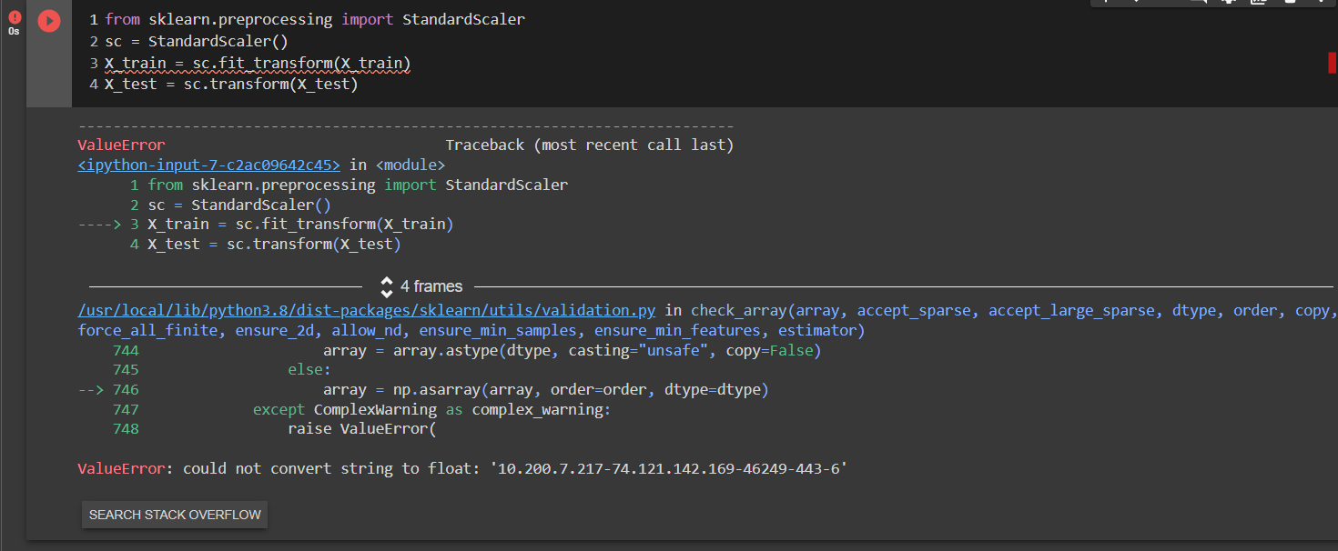

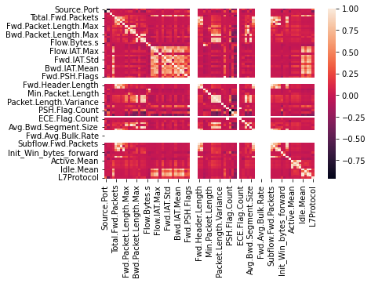

Taks we will be performing next week

* We will be performing dimensionality reduction.
* We will be analyzing the algorithms and their performance.